Additional recruitment for Erasmus+ mobility to non-European countries
recruitment of students for a semester-long mobility, summer semester of 2025/26
number of places available: 9 across WUST
recruitment from September 20, 2025, to October 3, 2025.
please send your application documents to: w8n.erasmus@pwr.edu.pl

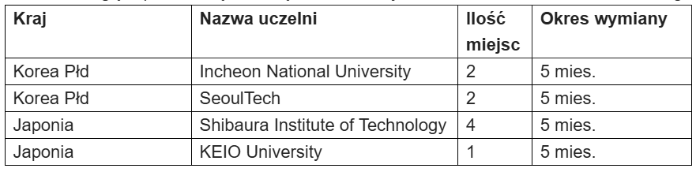

Students can view the course offerings of a given university in the Student Exchange section: https://crm.pwr.edu.pl/studenci/program-erasmus-plus/program-student-exchange
Documents to be submitted:
1. Application form,
2. Weighted average grades from the last semester – certificate from the Dean's Office,
3. Weighted average grades from the entire course of study – certificate from the Dean's Office,
4. Certificate of English language proficiency at a minimum level of B2+ or a completed language course at Wrocław University of Science and Technology (it is not possible to take a language exam at the SJO WUST).

Candidates' selection criteria, in addition to standard information as defined in the Erasmus+ Program Admission Regulations, will also include: academic achievements, community involvement, research interests, compliance with the program's objectives, and the content of a cover letter.

